Spring core

25-09-2025
Spring Core Introduction / Overview
- Shortcomings of Java EE and the Need for Loose Coupling
- Managing Beans, The Spring Container, Inversion of Control
- The Factory Pattern
- @Component, Auto-Detecting Beans
- Dependencies and Dependency Injection (DI) with the BeanFactory
- Setter Injection
Solid Principals
Spring Container
- The Spring Managed Bean Lifecycle
- Autowiring Dependencies

🌱 Managing Beans in Spring
In Spring, a bean is simply an object that is managed by the Spring IoC container. These beans are created, configured, and wired together by Spring, rather than manually in your code.
🔹 What is a Bean?
- A bean is a POJO (Plain Old Java Object) annotated with Spring annotations like @Component, @Service, @Repository, etc.
- Beans are automatically detected and registered in the Spring container if component scanning is enabled.
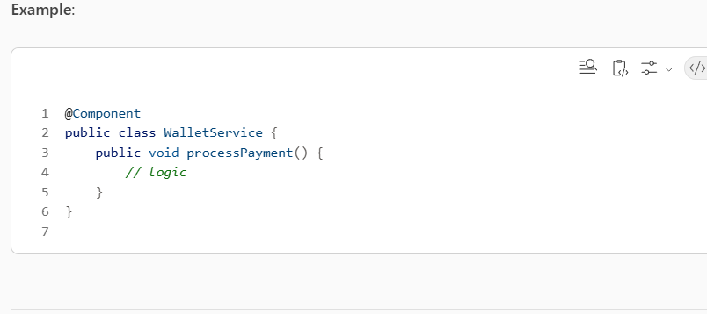

🧰 The Spring Container
The Spring Container responsible for:
- Instantiating beans
- Injecting dependencies
- Managing bean lifecycle
- Applying configuration
🔹 Types of Containers
- BeanFactory – Lightweight container, basic DI support.
- ApplicationContext – Full-featured container with support for:
  - Internationalization
  - Event propagation
  - AOP
  - Web applications

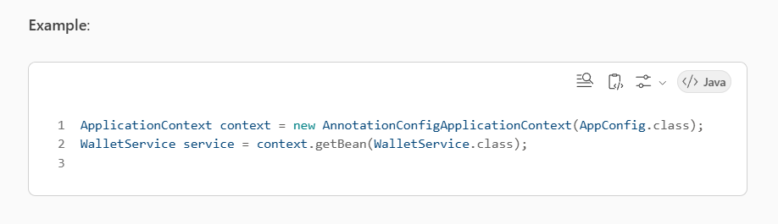

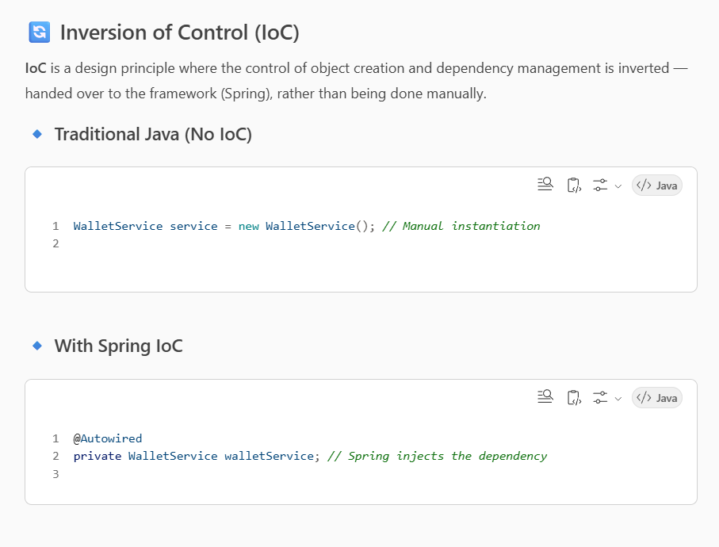

How Spring Manages Beans
- Component Scanning: Spring scans packages for classes annotated with @Component, @Service, etc.
- Dependency Injection: Spring injects required dependencies.
- Lifecycle Management: Spring manages initialization and destruction.

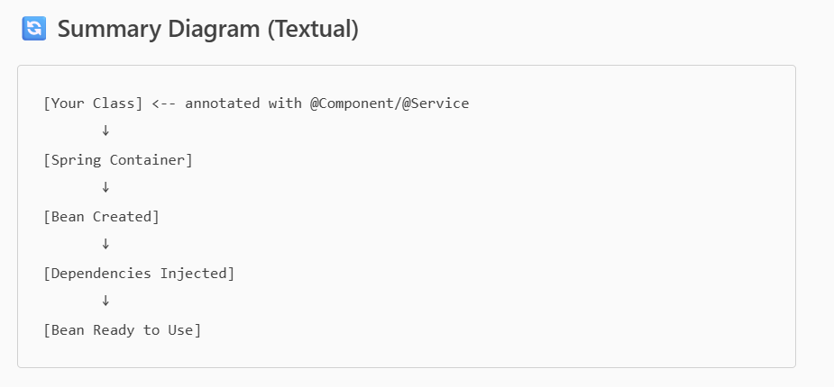

🏭 The Factory Pattern in Spring comes under (creational design pattern)
The Factory Pattern is a creational design pattern that provides a way to create objects without specifying the exact class of the object that will be created.
🔹 In Spring:
Spring uses the Factory Pattern internally to create and manage beans. we don’t instantiate objects manually; instead, Spring does it for you.

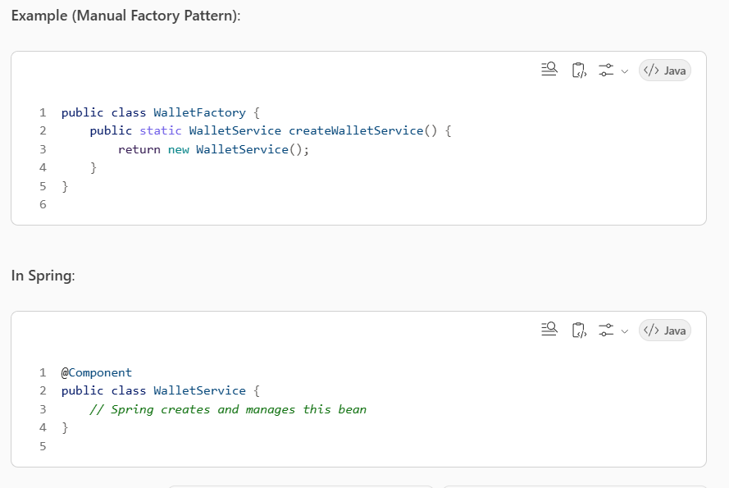

@Component and Auto-Detecting Beans
🔹 @Component
Marks a class as a Spring-managed bean. Spring will automatically detect it during component scanning.
Other specialized annotations:
- @Service – for service layer beans
- @Repository – for DAO layer beans
- @Controller – for web controllers
🔹 Auto-Detection
Spring scans packages using @ComponentScan and registers beans automatically.
Example:
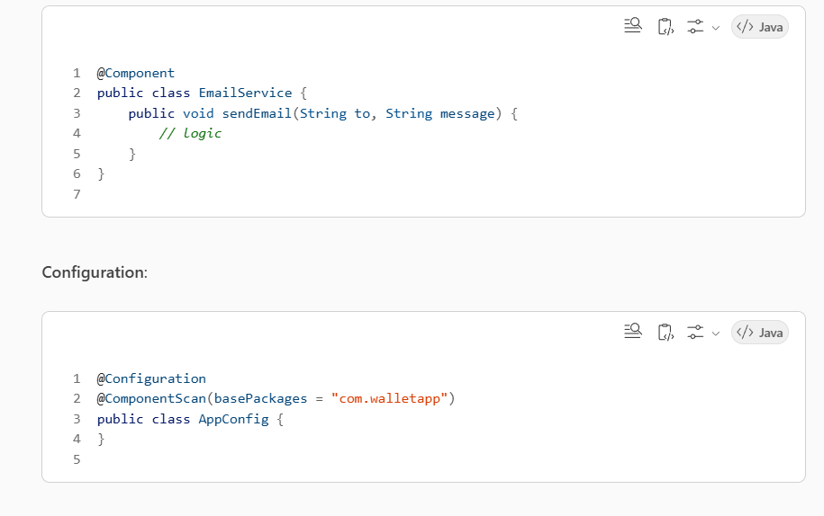

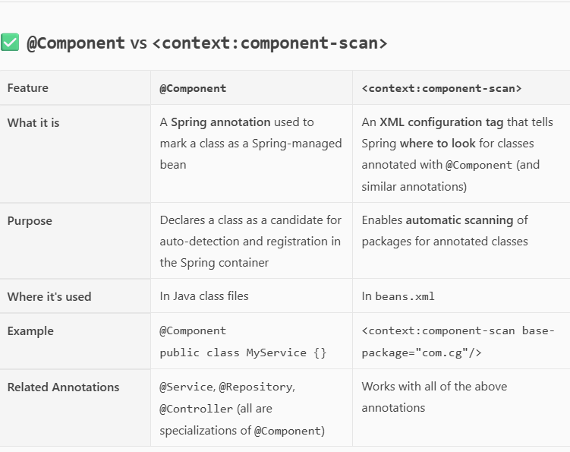

🧠 Dependency Injection (DI) with BeanFactory
🔹 BeanFactory
- The simplest container in Spring.
- Provides basic DI capabilities.
- Mostly replaced by ApplicationContext in modern Spring apps.

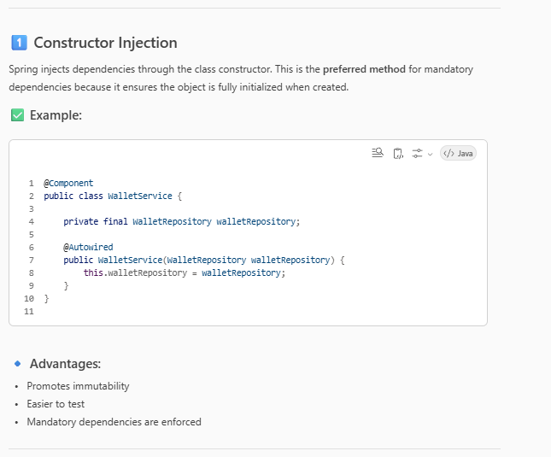
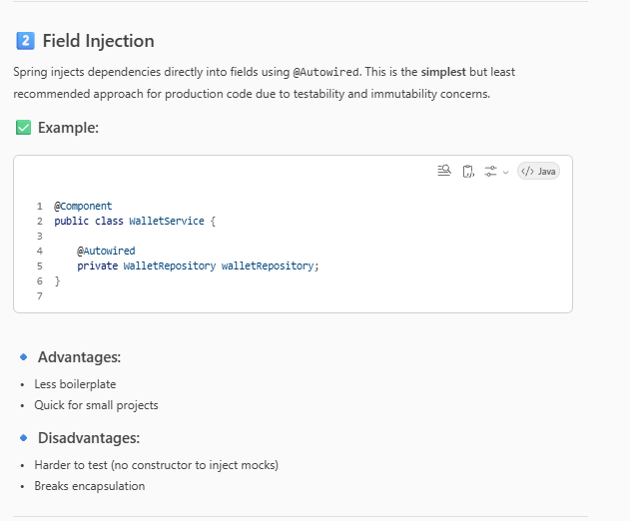
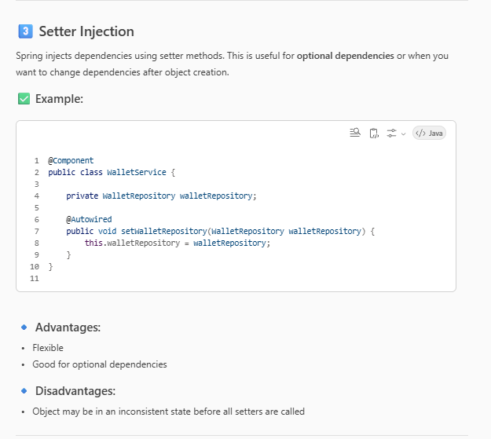

What is the SOLID principle with advantage
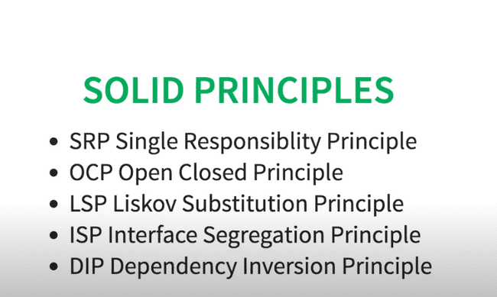

1.SingleResponsibility Principle-A class should have only one reason to change.
- Each class should do one thing and do it well.
- Example: A UserService should not handle logging or database operations — those should be separate classes.
Ex-single responsibility
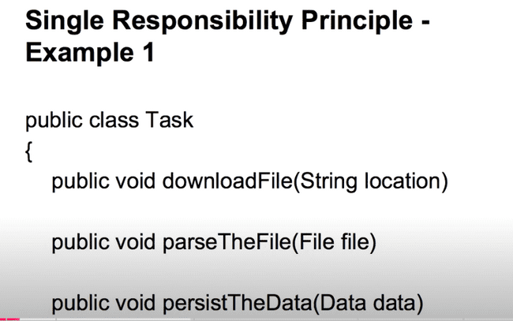

Not a single responsibility

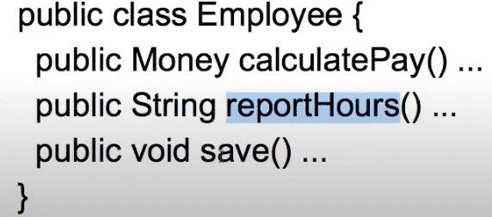

2.Open/closed principle.
Software entities should be open for extension, but closed for modification.
- You should be able to add new functionality without changing existing code.
- Example: Use interfaces and inheritance so new behaviors can be added via new classes.

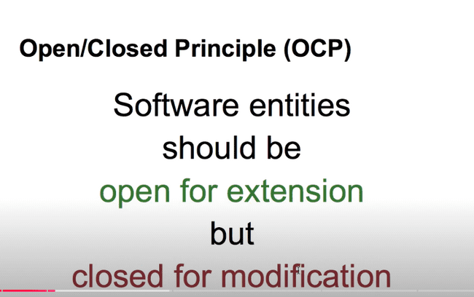
open for extension but closed for modification-
here we are calculating area of shapes
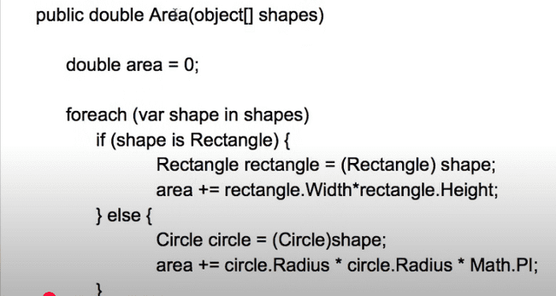
if we want to add

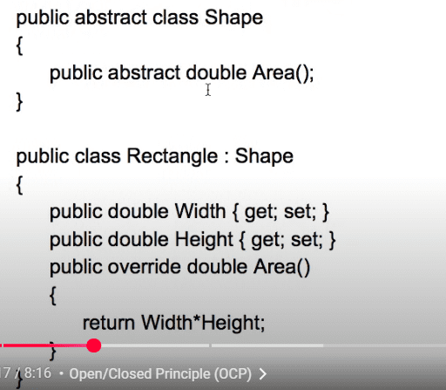
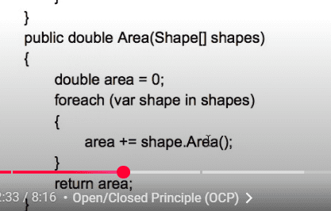

3. L — Liskov Substitution Principle (LSP)
Subtypes must be substitutable for their base types.
- If class B is a subclass of class A, then A's objects should be replaceable with B's objects without breaking the program.
- Example: If Bird has a method fly(), then Penguin (a subclass) should not override it in a way that breaks expectations.

4. 4. I — Interface Segregation Principle (ISP)
Clients should not be forced to depend on interfaces they do not use.
- Split large interfaces into smaller, more specific ones.
- Example: Instead of one Animal interface with fly(), swim(), walk(), create separate interfaces like Flyable, Swimmable, Walkable.

5. 5. D — Dependency Inversion Principle (DIP)
High-level modules should not depend on low-level modules. Both should depend on abstractions.
- Use interfaces or abstract classes so that high-level logic is not tightly coupled to low-level implementations.
- Example: A NotificationManager should depend on a NotificationService interface, not directly on EmailNotification.

Spring Container
- The Spring Managed Bean Lifecycle
- Autowiring Dependencies

🌱 Spring Container Overview
The Spring Container is the core of the Spring Framework. It is responsible for:
- Creating and managing beans
- Injecting dependencies
- Managing bean lifecycle
- Applying configurations
Spring provides two main types of containers:
- BeanFactory – Lightweight, basic DI support
- ApplicationContext – Full-featured container (used in Spring Boot)

🔄 Spring Managed Bean Lifecycle
Spring manages the lifecycle of beans from creation to destruction. Here's the typical lifecycle:
🔹 1. Instantiation
Spring creates the bean instance using the constructor or factory method.
🔹 2. Populate Properties
Spring injects dependencies via constructor, setter, or field injection.
🔹 3. Bean Initialization
Spring calls any initialization methods:
- @PostConstruct
- InitializingBean.afterPropertiesSet()
- Custom init methods defined in @Bean(initMethod = "init")
🔹 4. Bean Ready to Use
The bean is now fully initialized and can be used by the application.
🔹 5. Destruction
When the application context is closed, Spring calls:
- @PreDestroy
- DisposableBean.destroy()
- Custom destroy methods defined in @Bean(destroyMethod = "cleanup")
✅ Example:
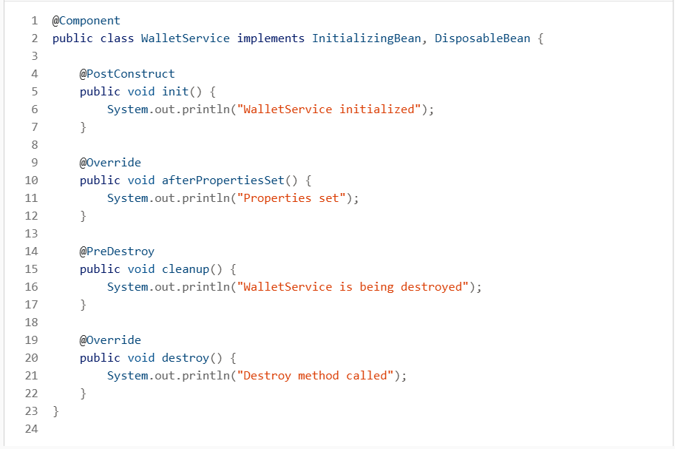

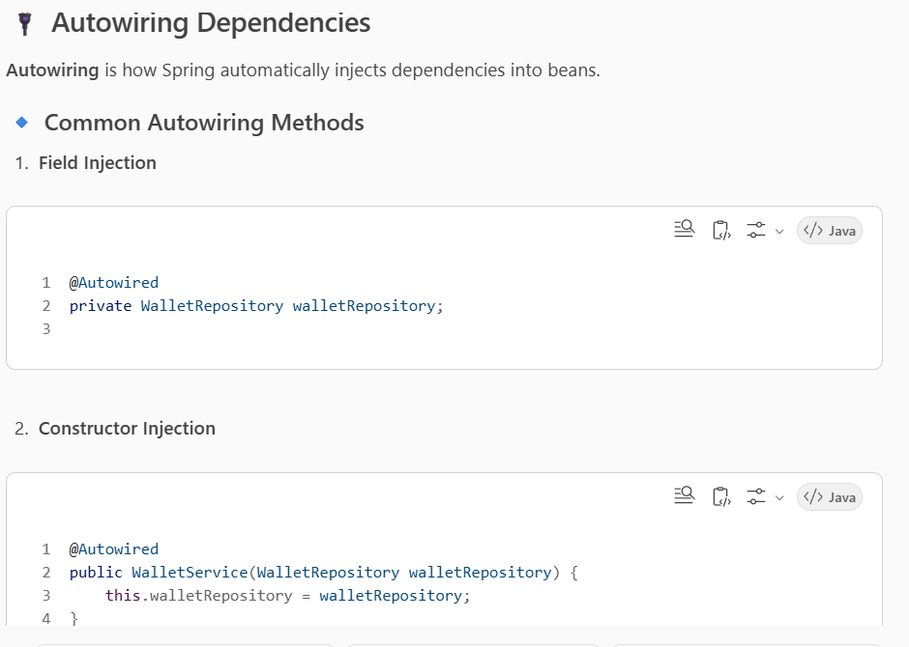

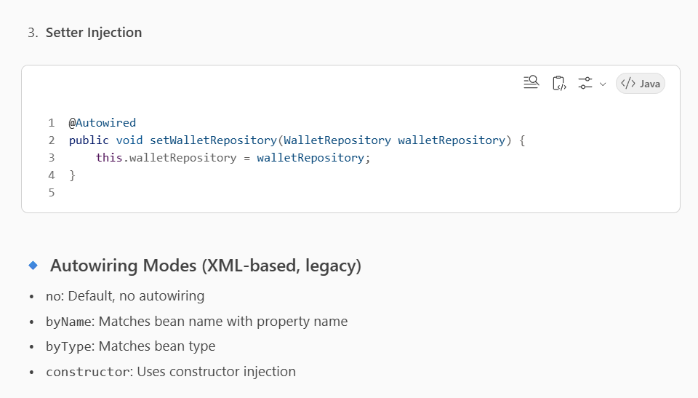
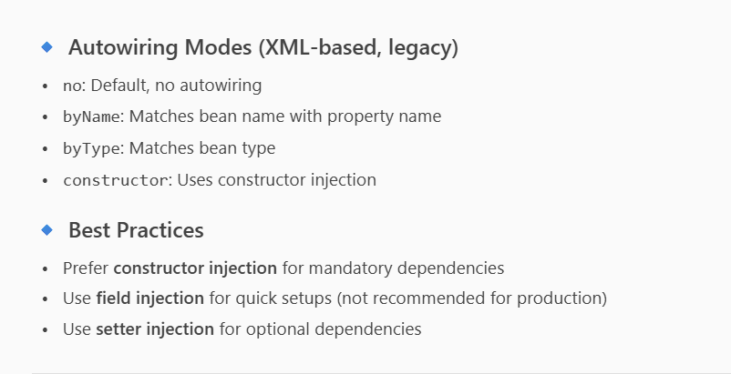
26-09-2025
Dependency Injection

Object creation in spring boot called dependency injection.
Dependency Injection is a technique whereby one object (or static method) supplies the dependencies of another object. A dependency is any object that another object requires to function correctly.

-

Using the Application Context
- Constructor Injection
- Factory Methods

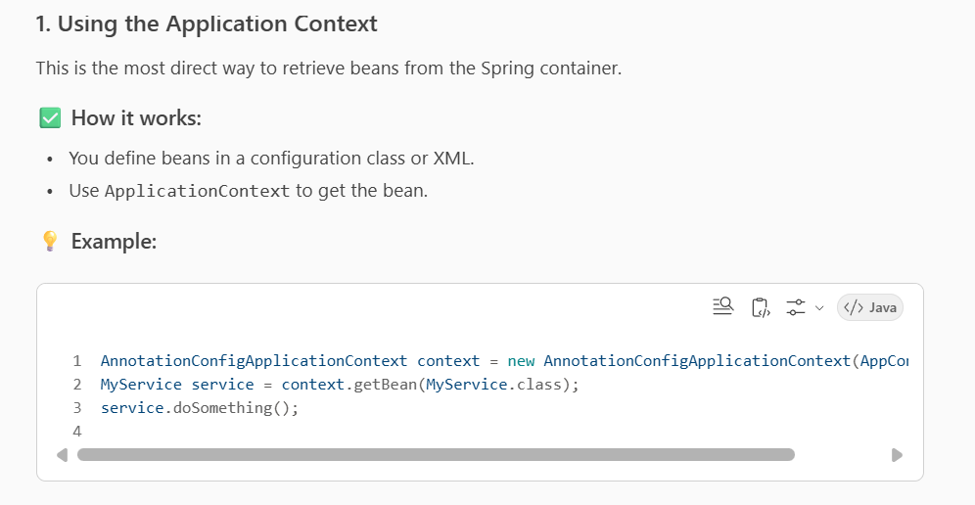

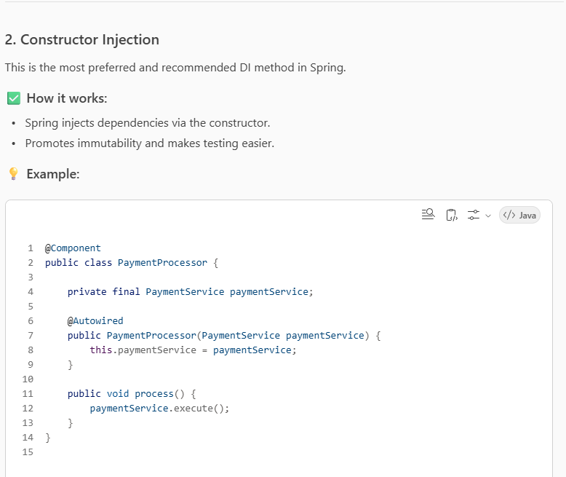

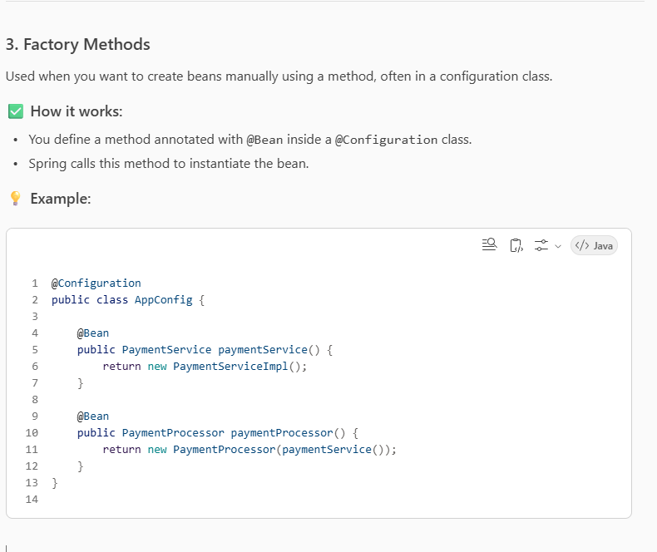

Metadata / Configuration
- Annotation Configuration @Autowired, @Required, @Resource
- @Component, Component Scans.

Annotation-Based Configuration
Spring allows you to configure beans using annotations instead of XML. Here are the key annotations:
1. @Autowired
- Automatically injects dependencies by type.
- Can be used on constructors, fields, or setter methods.

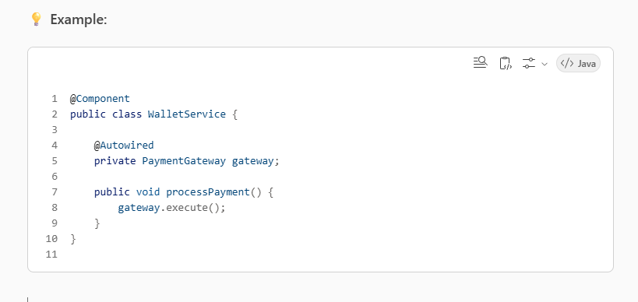

2. @Required (Deprecated)
- Ensures that a property is set via a setter method.
- If not set, Spring throws a BeanInitializationException.
💡 Example:
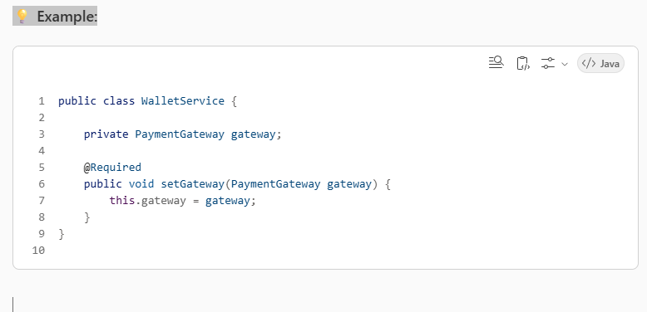

3. @Resource
- Comes from JDK (JSR-250).
- Injects by name first, then by type if name not found.
💡 Example:
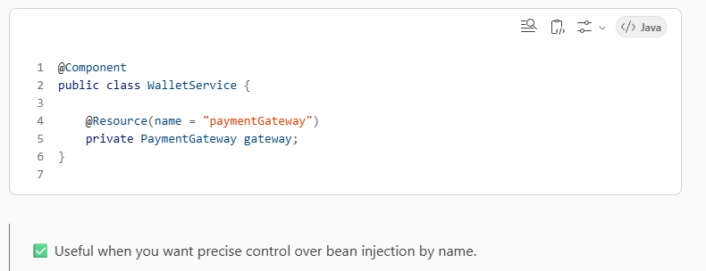

🧩 @Component and Component Scanning
@Component
Marks a class as a Spring-managed bean.
💡 Example:
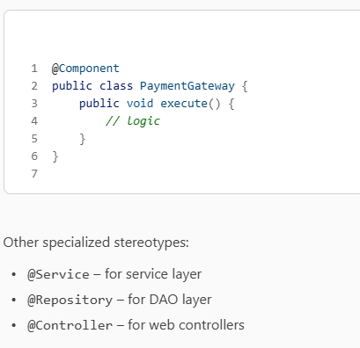

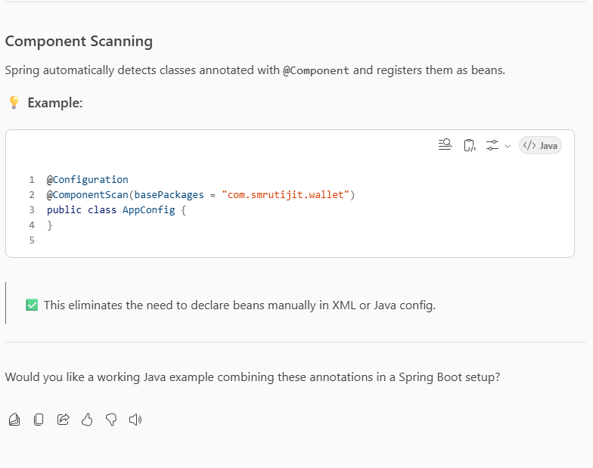

- Life Cycle Annotations
- Java Configuration, @Configuration, XML free configuration
- The Annotation Config Application Context
- Integration with JPA
- Transactions Management

🔄 Life Cycle Annotations in Spring
Spring provides several annotations to hook into the bean lifecycle:

1. @PostConstruct
- Marks a method to be executed after dependency injection is done.
- Runs once after the bean is fully initialized.
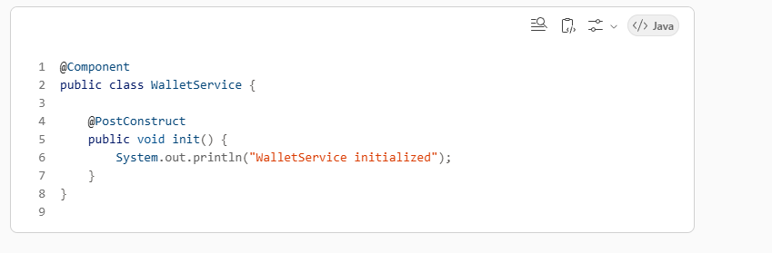
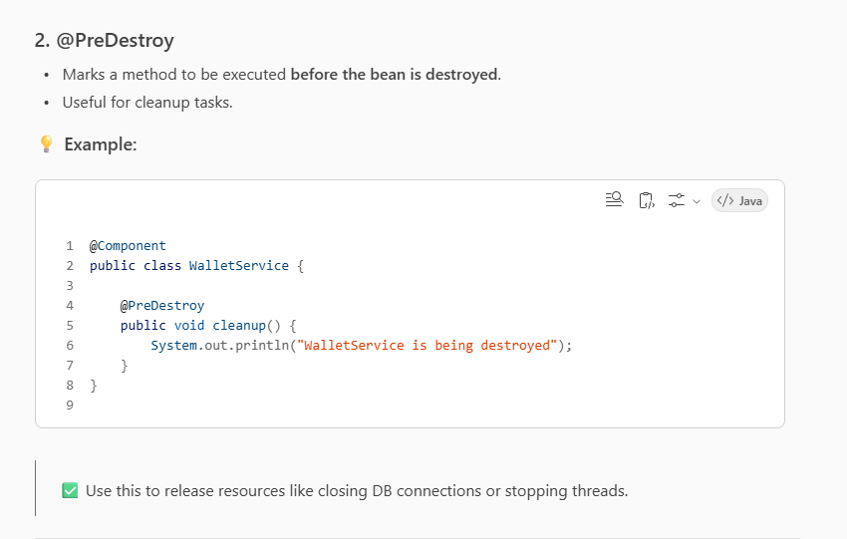
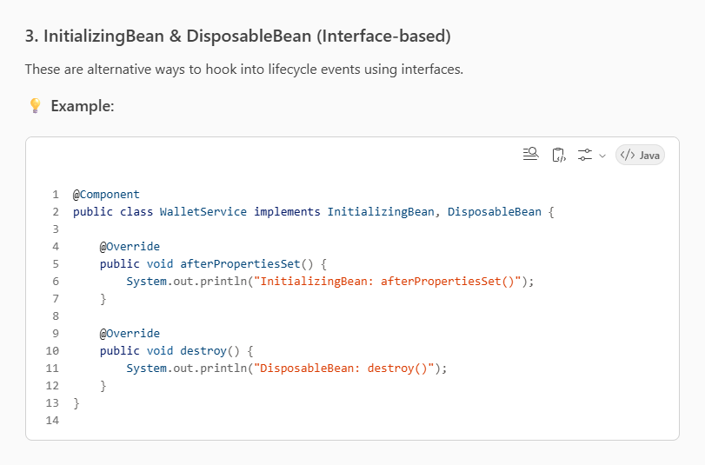
The Annotation Config Application Context
- Integration with JPA
- Transactions Management

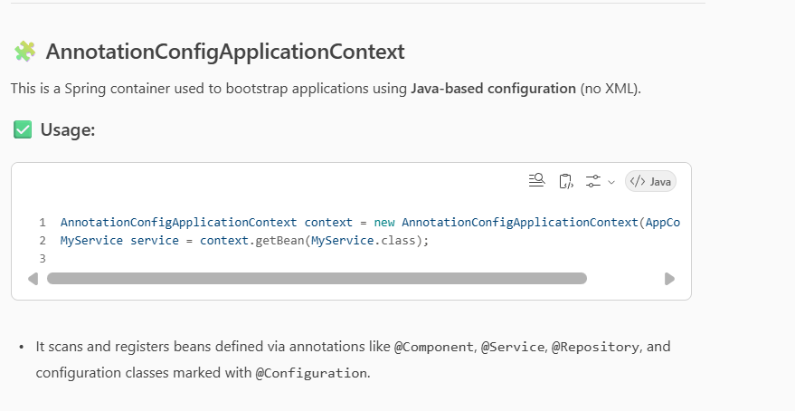

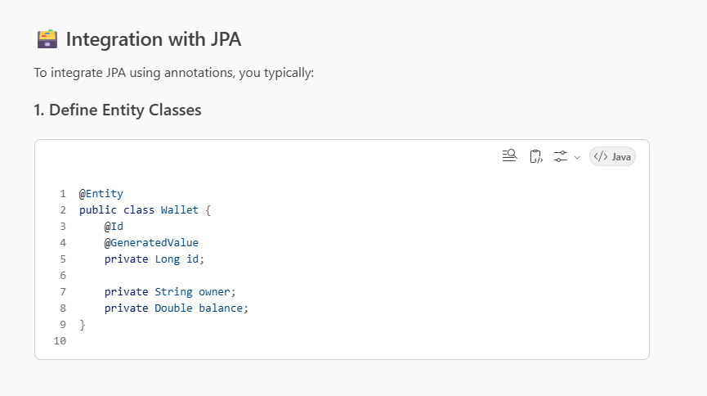
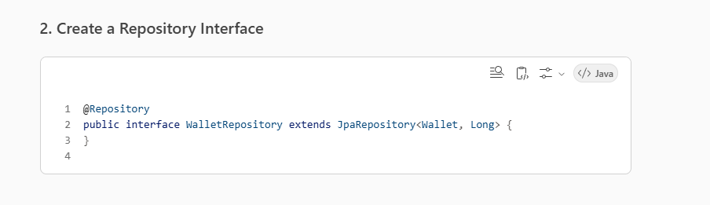
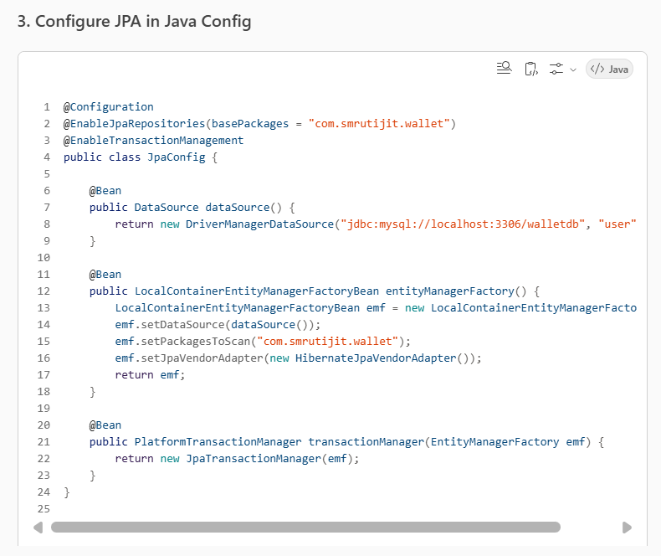

🔁 Transaction Management
Spring supports declarative transaction management using:
1. @EnableTransactionManagement
Activates annotation-driven transaction management.
2. @Transactional
Used to mark methods or classes as transactional.
💡 Example:
